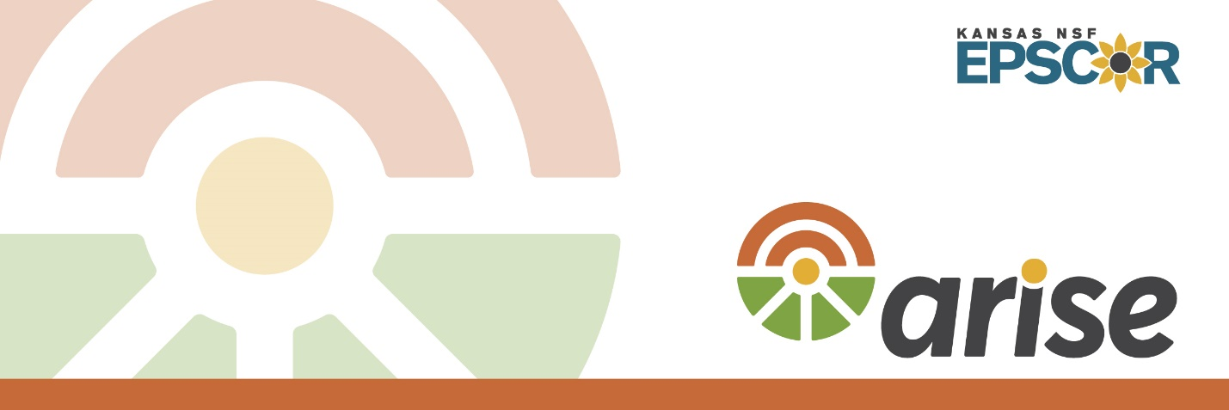

**Summary Report**

**ARISE Community Studio Part 1:**   
*Building Community Resilience and Social Equity with Community Assets and Capitals*

**Liberal, Kansas**

**2024**

A **community studio** is defined as a framework that sparks conversation between community members and researchers to uncover meaningful insights for a research project.

These activities are not extractive, simply pulling information from the communities. Rather, they are meant to support collaboration for the benefit of *both* the communities and the researchers. Both parties should find value in participation, leading to community-centered insights.

To that end, and as promised, this report summarizes what was learned from our first community studios on April 4, 2024 and June 11, 2024. We hope you find it insightful.

**Purpose and Overview**



On April 4, 2024 and June 11, 2024, 20 people gathered for three and half hours to participate in the first **ARISE Community Studios** in **Liberal, Kansas**

Their purpose: explore **community resilience** and **social equity** **Liberal Kansas** After a brief introduction, studio participants completed a series of activities, including a survey, storytelling activity, and an interactive asset “mapping” activity.

**Attendees included** **13 community partners** from economic development organizations, utilities, nonprofit organizations, community service organizations, museums, educational institutions, parks, and local businesses.

**Three researchers and staff** also participated in the studio from the ARISE Project. The studios were facilitated by Dr. Jason Bergtold from Kansas State University and Tonya Bronleewe and John Colclazier from Wichita State University.

O**bjectives** to identify at the studio:

* Traits of community resilience.
* Traits of social equity.
* Assets based on the community capitals framework and how these assets interlink with each other.
* Which assets influence community resilience and social equity.

Workshop Schedule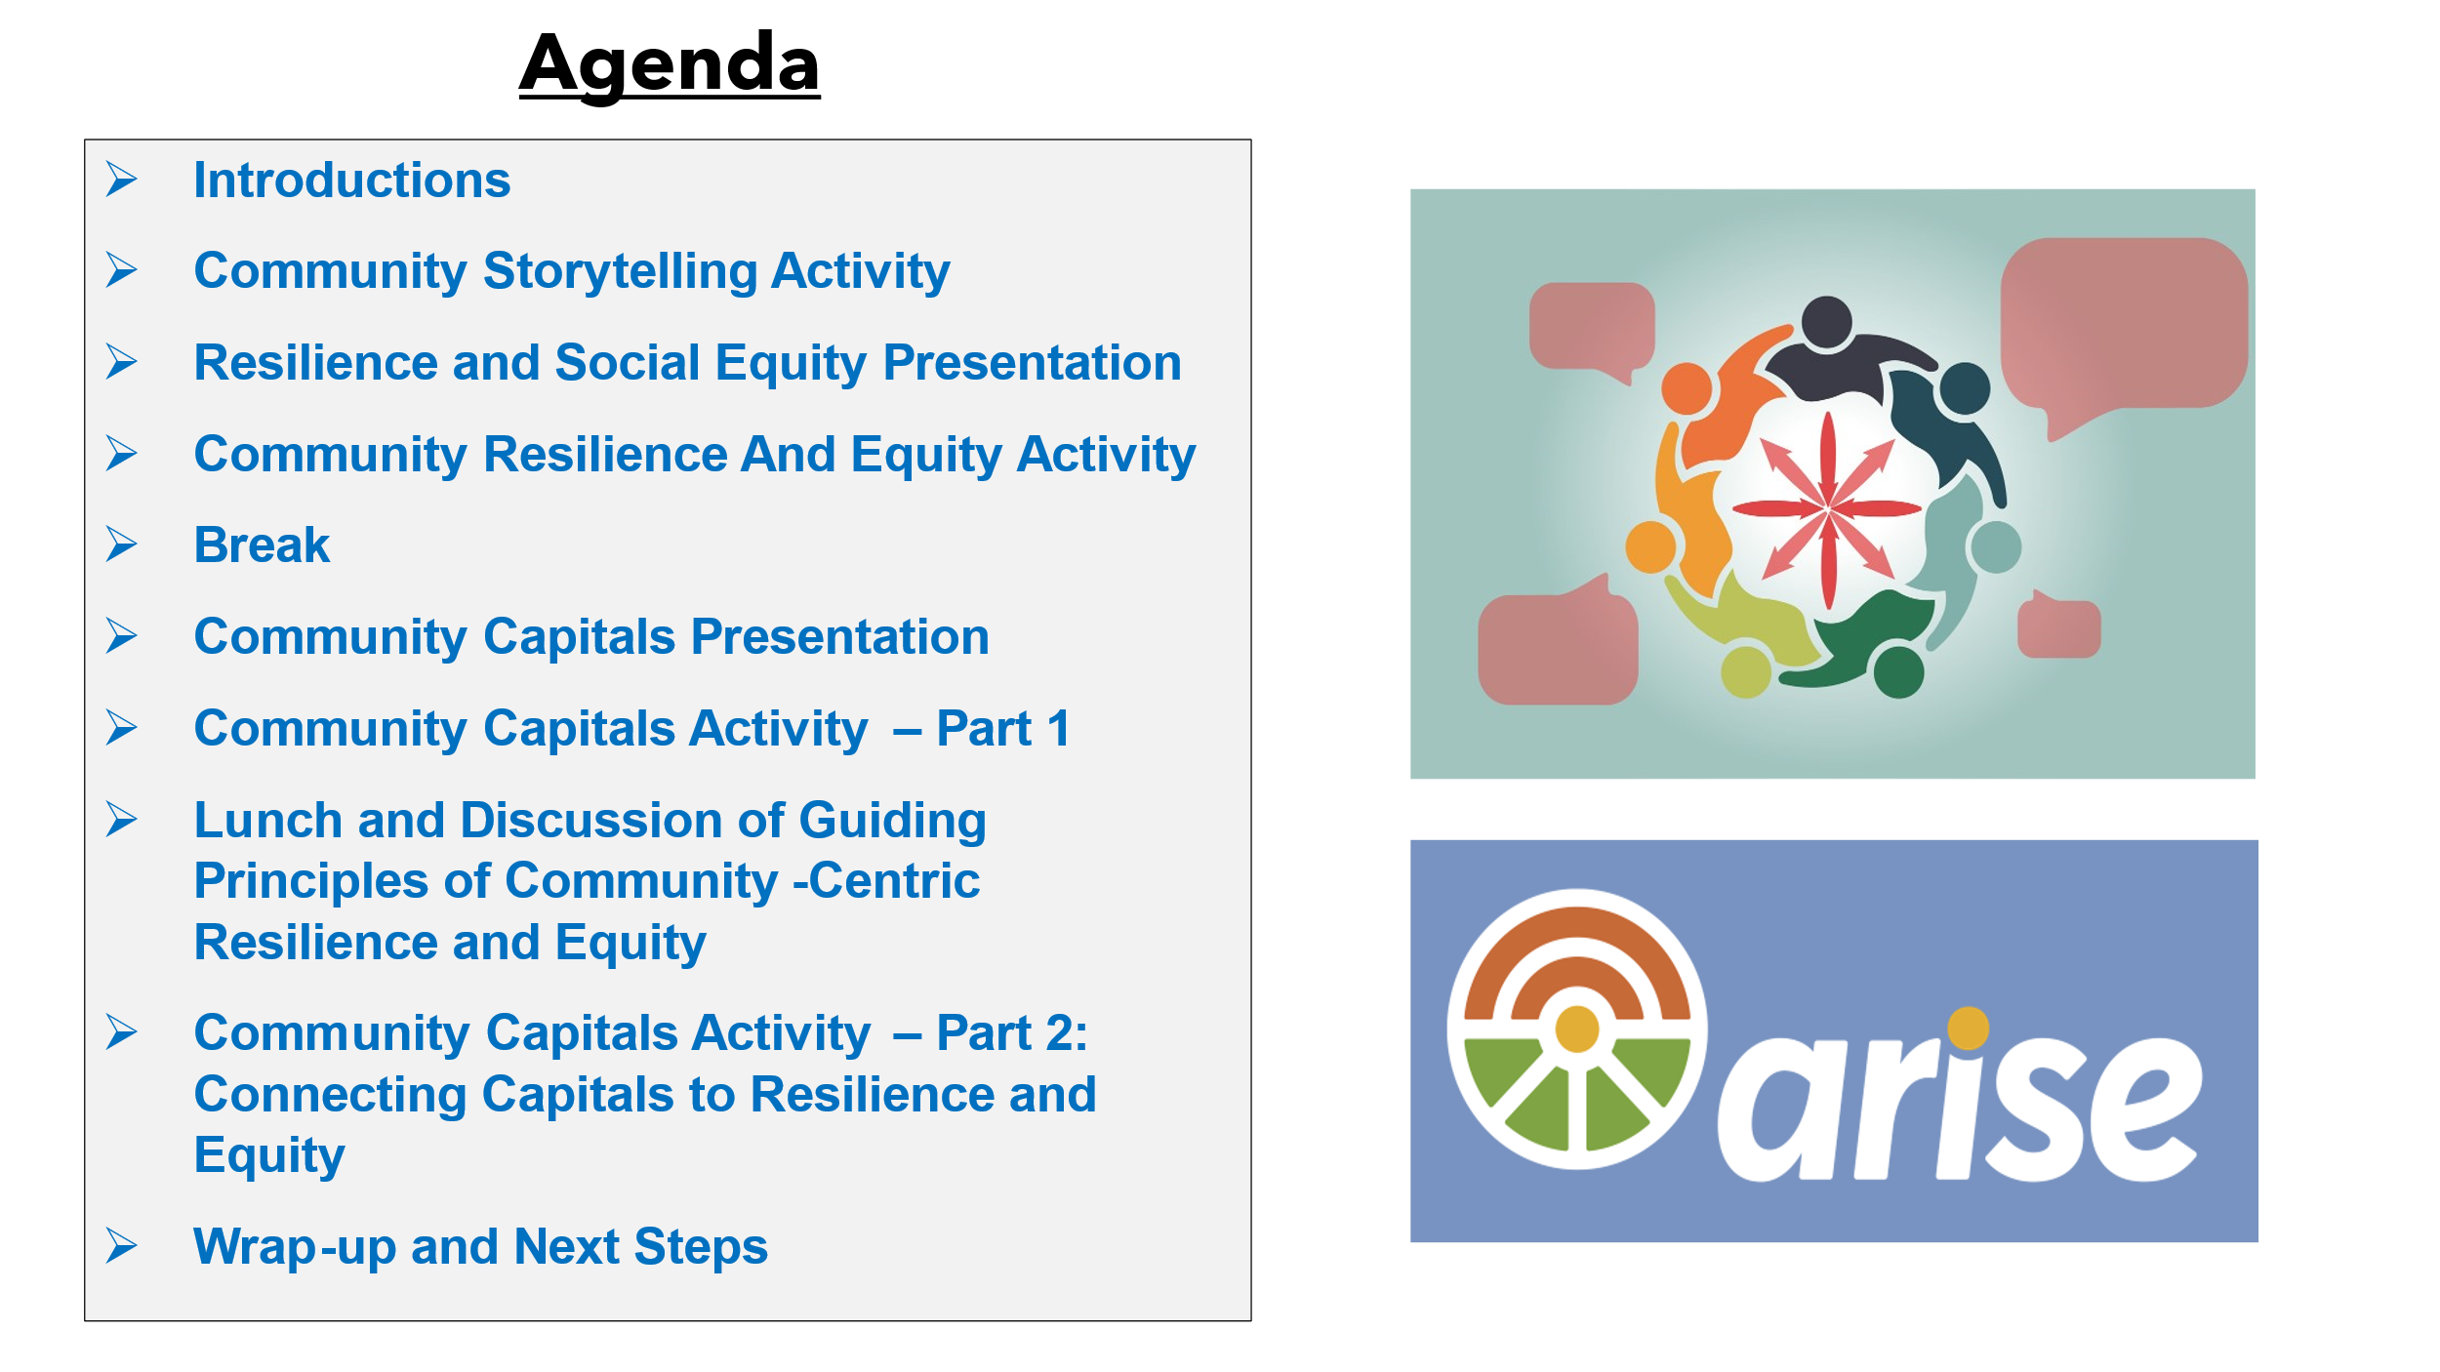

Toexplore community resilience and social equity for the community, the facilitators asked participants to complete a short exercise comparing aspects and guiding principles of resilience and equity. These aspects and guiding principles were things like having effective leadership and fairness and impartiality.

The guiding principles were developed based on a review of academic literature, prior focus group interviews in Kansas communities, and input from governmental and nonprofit organizations.

**What is resilience?** Resilience is the capacity of individuals, communities, businesses, institutions, and governments to adapt to changing conditions and to prepare for, withstand, and rapidly recover from disruptions to everyday life, such as hazard events, in the short and longer term.

**What is equity?** The term “equity” means the consistent and systematic fair, just, and impartial treatment ​of all individuals, including individuals who belong to underserved communities.

*As we present the results below, we recognize that different groups and individuals have their own ideas about community resilience and social equity. We also recognize that the guiding principles do not cover all aspects of community resilience and social equity for any given community, as each community will have unique contexts that need to be considered.*

**What aspects matter most for equity?**



**Here’s how participants ranked various aspects/guiding principles of social equity.**

|  |  |
| --- | --- |
| **Table 1:** Relative importance of alternative guiding principles and aspects of social equity for Liberal, KS | |
| **Relative Ranking** | **Guiding Principle** |
| Higher Ranked Aspects | Equal access to clean water, affordable energy, and transportation.  Equal access to educational, social and economic opportunities.  Recognition of social and economic needs across the population.  Everyone has access to their needed public services and resources. |
| Aspects Ranked in the Middle | Participation and representation of all groups in local governance.  No one has difficulty receiving public services.  Public policies do not disproportionately burden any specific group.  Respect for all voices and identities. |
| Lower Ranked Aspects | Everyone is able to participate in decision-making processes.  Outreach to groups with social needs.  Each household receives the same response to concerns.  Fairness and impartiality. |

The higher-ranked aspects could be seen as those aspects that provide an opportunity for making more significant improvements to **social equity** in the community.

**What aspects matter most for resilience?**



**Here’s how participants ranked aspects/guiding principles of community resilience.**

|  |  |
| --- | --- |
| **Table 2:** Relative importance of alternative guiding principles and aspects of community resilience for Liberal, KS | |
| **Relative Ranking** | **Guiding Principle** |
| Higher Ranked Aspects | Effective leadership.  Equitable access to infrastructure services (water, energy, and transportation).  Reliable access to community services (health, education, housing, child-care).  Equitable access to community services (health, education, housing, child-care).  Reliable access to infrastructure services (water, energy, and transportation). |
| Aspects Ranked in the Middle | Actively building capacity to withstand future hazards.  Strong and equitable emergency response.  Good communication between infrastructure services (water, energy, transportation) during emergencies.  Strong and reliable communication networks  Reliable and hardened infrastructure (water, energy, transportation). |
| Lower Ranked Aspects | Disaster and hazard preparedness plans and resources developed and ready.  All community members can easily access information about their water, energy and transportation services.  Reliable and sufficient labor force.  Effective early warning.  Community sticks together. |

The higher-ranked aspects could be seen as those aspects that provide an opportunity for making more significant improvements to **community resilience**.

**A note about interpreting rankings:** The rankings might not necessarily indicate that certain principles or aspects are not important or critical for a community. A community may rank “Community sticks together” lower relative to other aspects when their community is already strong in this area and may not need as much focus as others. The higher-ranked aspects could be seen as those aspects that provide an opportunity for making more significant improvements to community resilience and social equity in the community.

Participants teamed up to identify assets and capitals that support the lifeblood of their community. To do this, participants engaged in a storytelling activity. We emphasized telling stories of positive changes, success, and beneficial transformations in the community (Emery et al., 2006). We also inquired about other community capitals not identified in the stories.

**What is an asset?** Anything that we want to keep, build upon, and sustain for future generations. They are a useful thing, person, or quality in your community.

**What is a capital?** When assets used to build other assets or resources they become a community capital. Capitals can be invested in, saved up, or used up (Emery et al, 2005).

***These activities help set the stage for us to think about how to build on the assets and resources we have now to address the community’s needs in the future.***

C**ommunity capitals** are assets and resources in a community that allow the community to grow, prosper, improve social well-being, and be resilient. Table 3 presents the types of community capital.

|  |  |  |
| --- | --- | --- |
| **Table 3:** Community Capitals and Community Resilience | | |
| **Capitals** | **Description** | **Relevant Indicators for Resilience** |
| Human  **Construction worker female with solid fill** | Knowledge, education, skills, health, physical ability, management, and orientations of community members. | Job creation and stability, health access, food access, unemployment |
| Natural  **Hill scene with solid fill** | Resources (air, land, water, minerals, oil) and overall stability of ecosystems, weather, amenities, location. | Land use, carbon footprint, water supply and quality, flood mitigation, |
| Cultural  **Confetti ball with solid fill** | Traditions, languages, identity, values, beliefs. | Minority representation, changes in beliefs |
| Social**Group with solid fill** | Social associates, networks, reciprocity, and trust generated by groups in the community, social norms | Social capital index, disaster planning and preparedness, charity and donations |
| Political  **Gavel with solid fill** | Access to resources and ability and power to influence resource distribution and achieve internal goals. | Voter participation, public support, trust indices, organizational communication |
| Financial  **Bank with solid fill** | Monetary savings, income, investments, credit, wealth generation, fundraising. | Tax and energy revenues, income metrics and inequality, community savings |
| Built  **Electric Tower with solid fill** | Physical infrastructure, community lifelines, critical facilities and services. | Energy resilience metrics, infrastructure service levels, service disruptions |
| *Sources*: Cafer et al. (2019), Cui and Li, (2019), Stofferahn (2012). | | |

**A map of the community capitals for Liberal, KS is shown on the next page in Figure 1.**

*Note*: Not all community capitals are presented in Figure 1 (e.g. roads were not identified by participants for built capital). The capitals identified represent those assets and resources that can help lead to positive changes, outcomes, or transformation in the community.

* Small Business Owners
* Workforce
* Young and Growing Population
* SCCC
* USD480 and USD483
* Community Mental Health Center
* Kismet Volunteer Fire Department
* K-State Extension
* Migrant Population
* Liberal Fire Department
* Skills Classes
* Community Members
* Training
* Health Education for Cancer Mgmt.
* Social Workers
* Children Translators
* Aquifer
* Agricultural Land
* Parks
* Natural Gas and Oil Reserves
* Arkalon Park
* Walk Paths
* Cattle
* Golf Course
* Banks
* USDA-FSA
* Farm Credit
* Sponsor/Donor Base
* Small Business Loan Program
* Meat Packing Plants
* Local Foundations
* Individual Local Investors
* Seward County Development Corporation
* High Sales Tax
* Local/Small Businesses
* Community Donations
* National Beef
* Ethanol Plant
* Feed Lots
* COPE
* LEAD
* PED
* Hospital
* Volunteers
* WIC
* Local/Social Media
* Faith-Based Organizations
* National Response Org.
* Civic Organizations
* Rec Center
* Community Members
* Ministerial Alliance
* KU Med.
* Rehab Centers
* Dialysis Center
* Connections for Health Resources
* Liberal Area Coalition for Families
* American Kidney and Cancer Assoc.
* Shelters
* Warning Systems
* Baseball/ Softball Complex
* Soccer Fields
* Hospital
* Transportation System
* Waste Water Plant
* Southern Pioneer Electric
* National Helium
* Railroad
* Designated Downtown
* Heavy Equipment
* Broadband/Fiber Optic
* Airport
* Seward County Landfill
* City Water
* Black Hills Energy
* Sirens
* Solar and Wind Energy
* City Manager/Commissioners
* Police Department
* Legislative Connections
* County Government
* SCCC Trustees
* Council of Government
* School Board
* Democrat and Republican
* Committees
* Local Emergency Planning
* Increased Diversity of Elected Officials
* Obama Care Market Place
* Local Government
* FEMA
* Pancake Day International
* Dorothy’s House/Coronado
* Mid-America Air Museum
* Baker Arts Center
* Strong Community Identity
* Cultural Festival
* Duck Race
* Hispanic and Immigrant Community
* PRCA Rodeo
* 5-State Fair
* Restaurants and Food Trucks
* Cinco de Mayo
* Little World’s Fair
* Midwest Mindset
* Church
* Home Medical Remedies
* Arts and Crafts Festivals
* Dialects
* Adventure Bay Water Park

**Financial Capital**

**Built Capital**

**Natural Capital**

**Political Capital**

**Social Capital**

**Human Capital**

**Cultural Capital**

**Figure 1: Mapping Community Capitals for Liberal, Kansas**

For the final activity, small groups indicated how various community capitals influence resilience and social equity in the community using different colors. The colors used were:

* **Green** for a “Strong positive influence and it’s moving in the right direction.”
* **Blue** for a “Positive influence, but there is room for improvement.”
* **Yellow** for a “Lower influence and we need to work on this a bit more.”
* **Red** for a “No influence and currently needs a lot of work.”

The results were “averaged” across the small groups as shown in Table 4 below and on the next two pages. Given time constraints, not all community capitals were always rated by the groups, hence, some community capitals may not be present in Table 4. This does not mean they do not have an influence on community resilience and social equity or were not seen as important.

|  |  |  |
| --- | --- | --- |
| **Table 4: Influence of Community Capitals on Community Resilience and Social Equity** | | |
| **Capital Type** | **Community Resilience** | **Social Equity** |
| **Built**  **Capital**  **Electric Tower with solid fill** | |  | | --- | | Waste Water Plant  Southern Pioneer Electric  Seward County Landfill  City Water  Black Hills Energy  Baseball/Softball Complex  Soccer Fields | | Broadband/Fiber Optic  Airport  Sirens  Warning Systems | | Transportation Systems  Solar and Wind Energy  Shelters | | Hospital  Designated Downtown | | |  | | --- | | Waste Water Plant  Seward County Landfill  Baseball/Softball Complex | | Southern Pioneer Electric  Broadband/Fiber Optic  City Water  Black Hills Energy  Warning Systems | | Transportation Systems  Airport  Sirens  Solar and Wind Energy | | Hospital  Railroad  Designated Downtown  Shelters | |

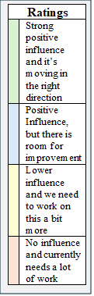

|  |  |  |
| --- | --- | --- |
| **Table 4: Influence of Community Capitals on Community Resilience and Social Equity** | | |
| **Capital Type** | **Community Resilience** | **Social Equity** |
| **Cultural Capital**  **Confetti ball with solid fill** | |  | | --- | | Pancake Day International  Midwest Mindset | | Dorothy’s House/Coronado  Baker Arts Center  Duck Race  Hispanic and Immigrant Community  Restaurants and Food Trucks  Church | | Mid-America Air Museum  Strong Community Identity  PRCA Rodeo  5-State Fair  Little World’s Fair  Church  Home Medical Remedies  Dialects  Adventure Bay Water Park | | *Nothing Listed in This Category* | | |  | | --- | | Restaurants and Food Trucks  Arts and Crafts Festival | | Dorothy’s House/Coronado  Culture Festival  Duck Race  Hispanic and Immigrant Community  Church | | Mid-America Air Museum  Baker Arts Center  Strong Community Identity  PRCA Rodeo  5-State Fair  Little World’s Fair  Midwest Mindset  Home Medical Remedies  Dialects  Adventure Bay Water Park | | *Nothing Listed in This Category* | |
| **Financial Capital**  **Bank with solid fill** | |  | | --- | | Feed Lots | | Banks  Small Business Loan Program  Meat Packing Plants  Local Foundations  Seward County Development Corporation  Local/Small Businesses  Community Donations  National Beef | | Sponsor/Donor Base  Individual Local Investors  High Sales Tax | | *Nothing Listed in This Category* | | |  | | --- | | Feed Lots | | Small Business Loan Program  Meat Packing Plants  Local Foundations  Seward County Development Corporation  Local/Small Businesses  Community Donations | | Banks  Sponsor/Donor Base  Individual Local Investors | | High Sales Tax | |

|  |  |
| --- | --- |
| **Ratings** | |
|  | Strong positive influence and it’s moving in the right direction |
|  | Positive Influence, but there is room for improvement |
|  | Lower influence and we need to work on this a bit more |
|  | No influence and currently needs a lot of work |

|  |  |
| --- | --- |
| **Ratings** | |
|  | Strong positive influence and it’s moving in the right direction |
|  | Positive Influence, but there is room for improvement |
|  | Lower influence and we need to work on this a bit more |
|  | No influence and currently needs a lot of work |

|  |  |  |
| --- | --- | --- |
| **Table 4 continued.** | | |
| **Capital Type** | **Community Resilience** | **Social Equity** |
| **Natural**  **Capital**  **Hill scene with solid fill** | |  | | --- | | *Nothing Listed in This Category* | | Agricultural Land  Parks  Arkalon Park  Walk Paths  Cattle | | Aquifer | | Natural Gas and Oil Reserves | | |  | | --- | | Parks | | Aquifer  Arkalon Park  Walk Paths  Cattle  Golf Course | | Natural Gas and Oil Reserves | | Agricultural Land | |
| **Human**  **Capital**  **Construction worker female with solid fill**  **Construction worker male with solid fill** | |  | | --- | | Small Business Owners  Workforce  Young and Growing Population | | SCCC  USD480 and USD483  K-State Extension  Migrant Population  Liberal Fire Department  Skill Classes  Training  Social Workers | | Community Mental Health Center  Kismet Volunteer Fire Dept.  Community Members  Health Education for Cancer Management | | *Nothing Listed in This Category* | | |  | | --- | | Workforce | | Small Business Owners  Young and Growing Population  SCCC  USD480 and USD483  K-State Extension  Migrant Population  Liberal Fire Department  Skill Classes  Training | | Community Mental Health Center  Kismet Volunteer Fire Department  Community Members  Health Education for Cancer Management  Social Workers | | *Nothing Listed in This Category* | |

|  |  |  |
| --- | --- | --- |
| **Table 4 continued.** | | |
| **Capital Type** | **Community Resilience** | **Social Equity** |
|  | | |
| **Social**  **Capital**  **Group with solid fill** | |  | | --- | | Faith-Based Organizations  Liberal Area Coalition for Families  Rec Center | | Civic Organizations  LEAD  Community Members  Ministerial Alliance  American Kidney and Cancer Association  Dialysis Center  Volunteers  Connections for Health Resources  WIC | | Local/Social Media  COPE  Hospital  KU Med. | | Rehab Centers | | |  | | --- | | Faith-Based Organizations  Liberal Area Coalition for Families  Rec Center | | Civic Organizations  COPE  LEAD  WIC | | Local/Social Media  Hospital  Community Members  Ministerial Alliance  American Kidney and Cancer Association  KU Med.  Dialysis Center  Volunteers  Connections for Health Resources | | Rehab Centers | |
| **Political**  **Capital**  **Gavel with solid fill** | |  | | --- | | *Nothing Listed in This Category* | | City Manager/Commissioners  Police Department  Increased Diversity of Elected Officials  SCCC Trustees  Council of Government  School Board  Local Emergency Planning  Local Government  FEMA | | County Government | | Legislative Connections | | |  | | --- | | Council of Government | | City Manager/ Commissioners  Increased Diversity of Elected Officials  SCCC Trustees  School Board  Local Emergency Planning  Obama Care Market Place  Local Government  FEMA | | County Government  Democrat and Republican Committees  Legislative Connections | | *Nothing Listed in This Category* | |

|  |  |
| --- | --- |
| **Ratings** | |
|  | Strong positive influence and it’s moving in the right direction |
|  | Positive Influence, but there is room for improvement |
|  | Lower influence and we need to work on this a bit more |
|  | No influence and currently needs a lot of work |

**References:**

Cafer A, Green J, Goreham G. 2019. A community resilience framework for community development practitioners building equity and adaptive capacity. *Community Development* 50(2): 201 – 216.

Cui P, Li D. 2019. Measuring the disaster resilience of an urban community using ANP-FCE method from the perspective of capitals. *Social Science Quarterly* 100(6): 2059 – 2077.

Emery M, Fey S, Flora C. 2006. Using community capitals to develop assets for positive community change. *CD Practice* 13:1-19.

Stofferahn CW. 2012. Community capitals and disaster recovery: Northwood ND recovers from an EF4 tornado. *Community Development* 43(5): 581 – 598.

Logo - https://commons.wikimedia.org/wiki/File:Logo_of_Liberal,_Kansas.png

|  |  |
| --- | --- |
| **Ratings** | |
|  | Strong positive influence and it’s moving in the right direction |
|  | Positive Influence, but there is room for improvement |
|  | Lower influence and we need to work on this a bit more |
|  | No influence and currently needs a lot of work |

The community studio was sponsored and organized by ARISE. This 5-year project seeks to build research capacity across Kansas while also strengthening the state’s economy and workforce. The National Science Foundation Established Program to Stimulate Competitive Research (EPSCoR) and Kansas Board of Regents fund us. The ARISE team of scientists seeks to help Kansas communities safeguard infrastructure in the face of increasingly severe weather, cyberattacks, and other disasters. But rather than looking for answers just in the lab—they are co-creating solutions *with* Kansas residents.

A key goal is to develop a new social equity-driven paradigm for resilience analysis through a pipeline of community leaders and decision-makers. This is an important research topic because the most socially vulnerable people tend to live and work in the most physically vulnerable areas (e.g., floodplains) with undersized or undermaintained infrastructure.

Learn more at: [arisekansas.org](https://ksuemailprod-my.sharepoint.com/personal/bergtold_ksu_edu/Documents/Eliyasu%20and%20Jason%20ARISE/ARISE%20Community%20Studio/Dodge%20City/arisekansas.org)

To conduct this research, the team connects with residents from five regions in Kansas: (i) Dodge City and Ford County; (ii) Garden City and Finney County; (iii) Liberal and Seward County; (iv)Kansas City and Wyandotte and Johnson Counties. ARISE research centers on [four themes](https://www.nsf.gov/awardsearch/showAward?AWD_ID=2148878&HistoricalAwards=false), as shown below. Other components of the project build talent in Kansas, including data science training, summer research experiences for college students, and hands-on science for youth and families.

**Acknowledgements**



**Studio, content, and report prepared by:**

Jason Bergtold, Department of Agricultural Economics, Kansas State University

Tonya Bronleewe, Environmental Finance Center, Wichita State University

John Colclazier, Environmental Finance Center, Wichita State University

Eliyasu Osman, Department of Agricultural Economics, Kansas State University

Alej Martinez, Kansas NSF EPSCoR Office, University of Kansas

**Edito**r: Claudia Bode, Kansas NSF EPSCoR Education, Outreach, and Diversity Director

***This material is based upon work supported by the National Science Foundation under Award No. OIA-2148878 and matching support from the State of Kansas through the Kansas Board of Regents.*** ***Any opinions, findings, and conclusions or recommendations expressed in this material are those of the author(s) and do not necessarily reflect the views of the National Science Foundation.***